**Section 1: Define / Answer**

Data Structure- A way to organize data.

Array: Type of data structure. Holds multiple values of the same primitive data type. In C++ they are fixed in size. The number of items must be decided at creation and it is difficult to change.

Represents a set of primitive data types with 1 variable name.

Items in an array are organized in relation to the array in which it is stored index. Its address is called its index.

Primitive Data Type Variables:  
double, int, char, float, short float, long float,

What is an object?  
Also a combination of primitive data types

Array Element: An item or value inside a specific array location

Array *Index:* Address or location

# of Indices = # of total elements - 1

Number of elements?

How is 0 used? 0 is the first index of an array

Array Initializers?

|  |  |  |  |  |
| --- | --- | --- | --- | --- |
| 1st Position  For Data | 2nd Position  For Data | 3rd Position  For Data | 4th Position  For Data | 5th Position  For Data |
| 0 | 1 | 2 | 3 | 4 |

Iterator-

Counts or check each item in a list.  
To iterate through an array in C++, you could use a for loop

Task 1- Page 201 # 1:

Show two ways to declare a one-dimensional array of 12 doubles.

{1.0, 2.0, 3.0, 4.0, 5.0, 6.0,7.0, 8.0, 9.0, 10.0, 11.0, 12.0};

For the first example print the 7.0 and 10.0 in a println.

Example - Your println should match

7.0

10.0

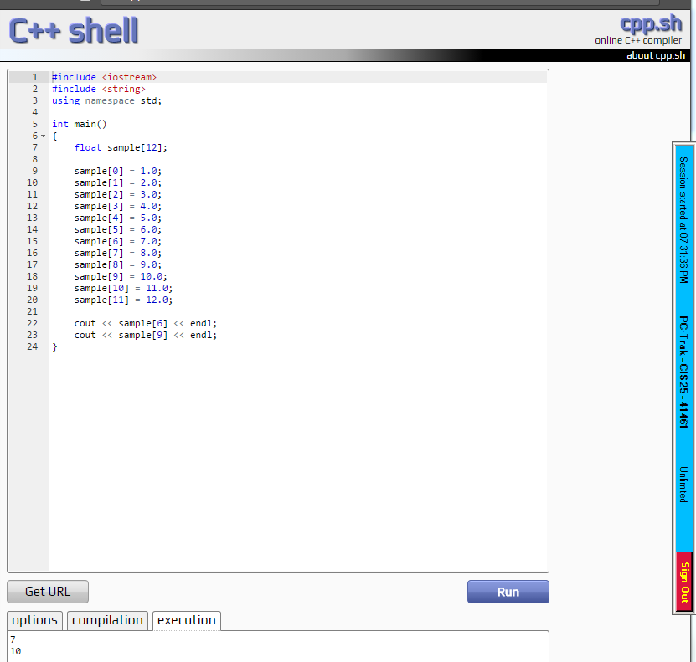

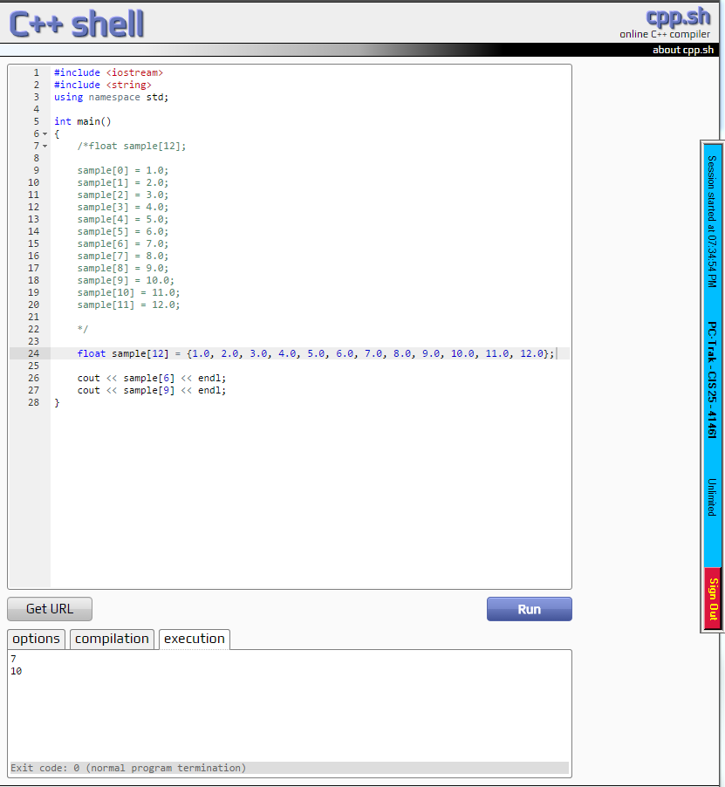

For the second example print the 2.0 and 12.0 in a println.

Example - Your println should match

2.0

12.0

Attach a 2 different snipping photos. The Snipping photos should include the programmer source code and the outputs.

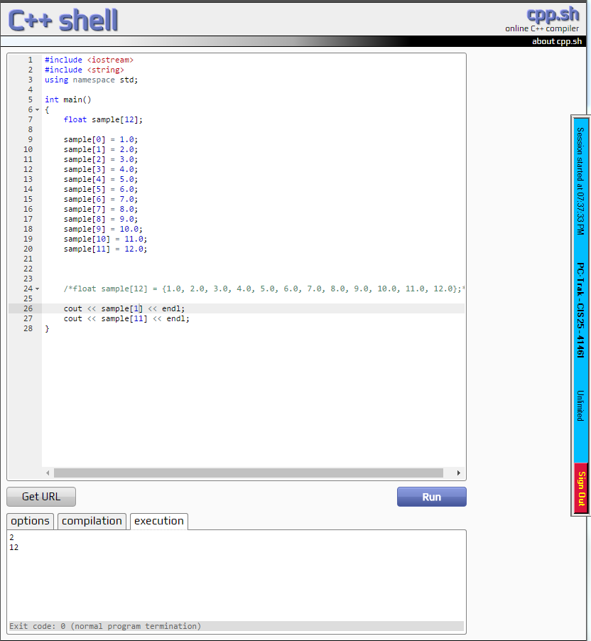

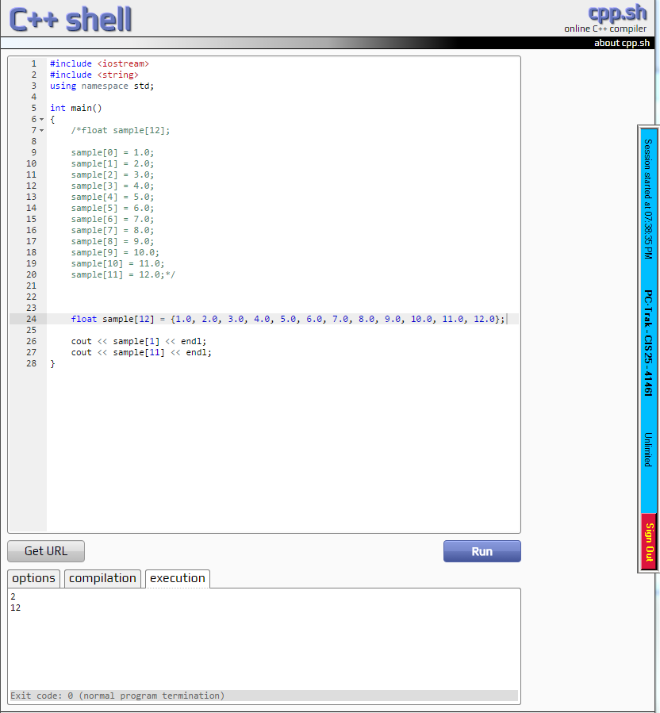

Task 2- Page 201 #3:

Write a program that uses an array to find the Average of 10 double values.

Allow the use to enter values for the 10 double numbers. A **for** loop will facilitate the user input of the 10 random values.

Then use a different **for** loop to iterate through the array summing the total for all 10 double values.

Output the list of numbers input by user.

Output the average of all the numbers.

Attach Snipping photos of source code and output.

